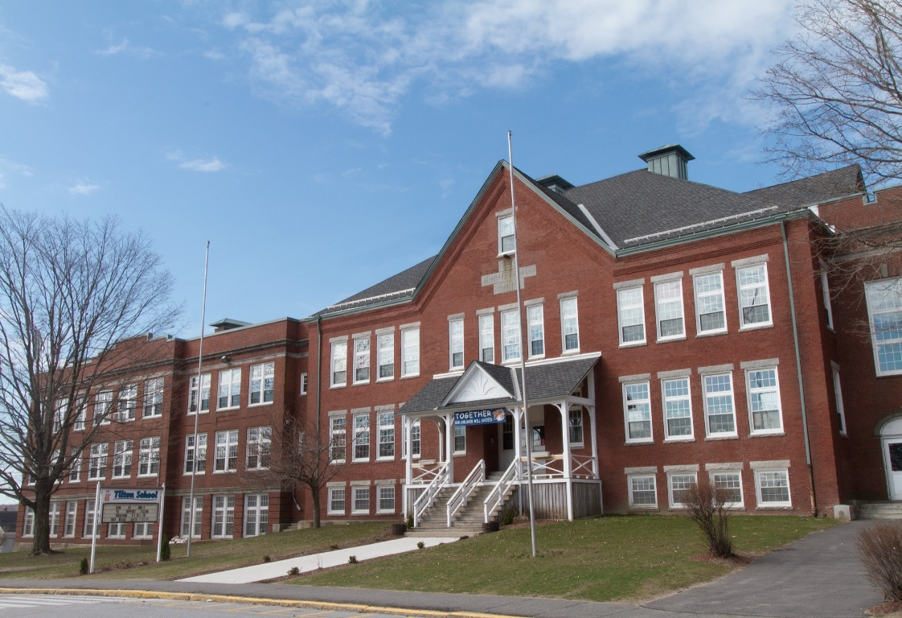

MINIMUM CAPACITY :-
The Minumum intake capacity
of students is between 300-620
children

LIBRARY :-
The Libarary is Available.

CANTEEN:-
The Canteen Facility is Available.

BOARDING :-
No availablility of boarding.

SPORTS :-
There are different categories
sports available.
Girls Volleyball
Boys Volleyball
Football

TILTON SCHOOL
UTICA - SCHOOL

School Detail :-
Tilton is a New Hampshire prep school that prepares students to embrace and navigate a world driven by diversity and change. Through the quality of human relationships, Tilton’s community cultivates in its students the curiosity, the skills, the knowledge and understanding, the character, and the integrity requisite for the passionate pursuit of lifelong success and service.
Tilton’s community cultivates in its students the curiosity, the skills, the knowledge and understanding, the character, and the integrity requisite for the passionate pursuit of lifelong success and service.

